

CSE370: Database Systems
Project Report
Project Title: Disaster Relief Management System

Group No: 8, CSE370 Lab Section: 11, Summer 2026
ID | Name | Contribution
24301374 | Shadeed Aarshan
24301362 | Nuzhat Tabassum Oishee
24301348 | Kazi Aryan Rahman

Table of Contents

Section  No | Content | Page No
1 | Introduction | 3
2 | Project Features | 3
3 | ER/EER Diagram
4 | Schema Diagram
5 | Normalization
6 | Frontend Development
7 | Backend Development
8 | Source Code Repository
9 | Conclusion
10 | References

Introduction

The idea behind our DBMS project is “Disaster Relief System” which takes a real life problem of civilians suffering from natural disasters and creates a prototype of a solution that can manage the relief system during these times. Our system will allow users to view disaster zones and sign up as volunteers to help victims.

Project Features

ID,  Name | Features
 | Ft 1 | Login
24301374,  Shadeed Aarshan | Ft 2 | Customers can view disaster zones and apply to be volunteers
 | Ft 3 | Admin can approve/delete volunteers
 | Ft 4 | Admin can deploy/release volunteers to and from disaster zones
 | Ft 5 | Volunteers can toggle availability, controlling whether they can be deployed or not
24301348,  Kazi Aryan Rahman | Ft 1 | Admin can declare, view, and update disaster zones, assigning a severity level and source warehouse
 | Ft 2 | Admin can dispatch relief supplies from a warehouse to a disaster zone, with automatic stock deduction and shipment logging
 | Ft 3 | Admin can view live per-zone analytics — active personnel, accumulated hours, and supplies dispatched
23101997,  DEF | Ft 1 | Warehouse Management and Inventory Assignment: Register warehouses, view/remove/edit warehouses and shelf locations
 | Ft 2 | Inventory Stock Monitoring and Low Stock Management: view inventory items, add/remove/update inventory
 | Ft 3 | Expiry Date Auditor: view remaining days until expiry, flag expired, and soon-to-be expired items

ER/EER Diagram

Schema Diagram

Normalization

- Explain if your converted Schema is in 1NF or not. If not, decompose it to 1NF.
- Explain if your converted Schema is in 2NF or not. If not, decompose it to 2NF. Can there be any partial functional dependencies in your relational schema?
- Explain if your converted Schema is in 3NF or not. If not, decompose it to 3NF. Can there be any transitive dependencies in your relational schema?

Answer:
- During schema mapping, it is automatically converted to 1NF as there are no multivalued or composite attributes
- Yes, it is in 2NF because there are no functional dependencies
- Yes, it is in 3NF because there are no transitive dependencies

Frontend Development

Briefly discuss about Backend Development and add relevant Screenshots (if required) by mentioning Individual Contributions

Contribution of ID: 24301374, Name: Shadeed Aarshan

In the backend section, I designed the following pages:

Login page:
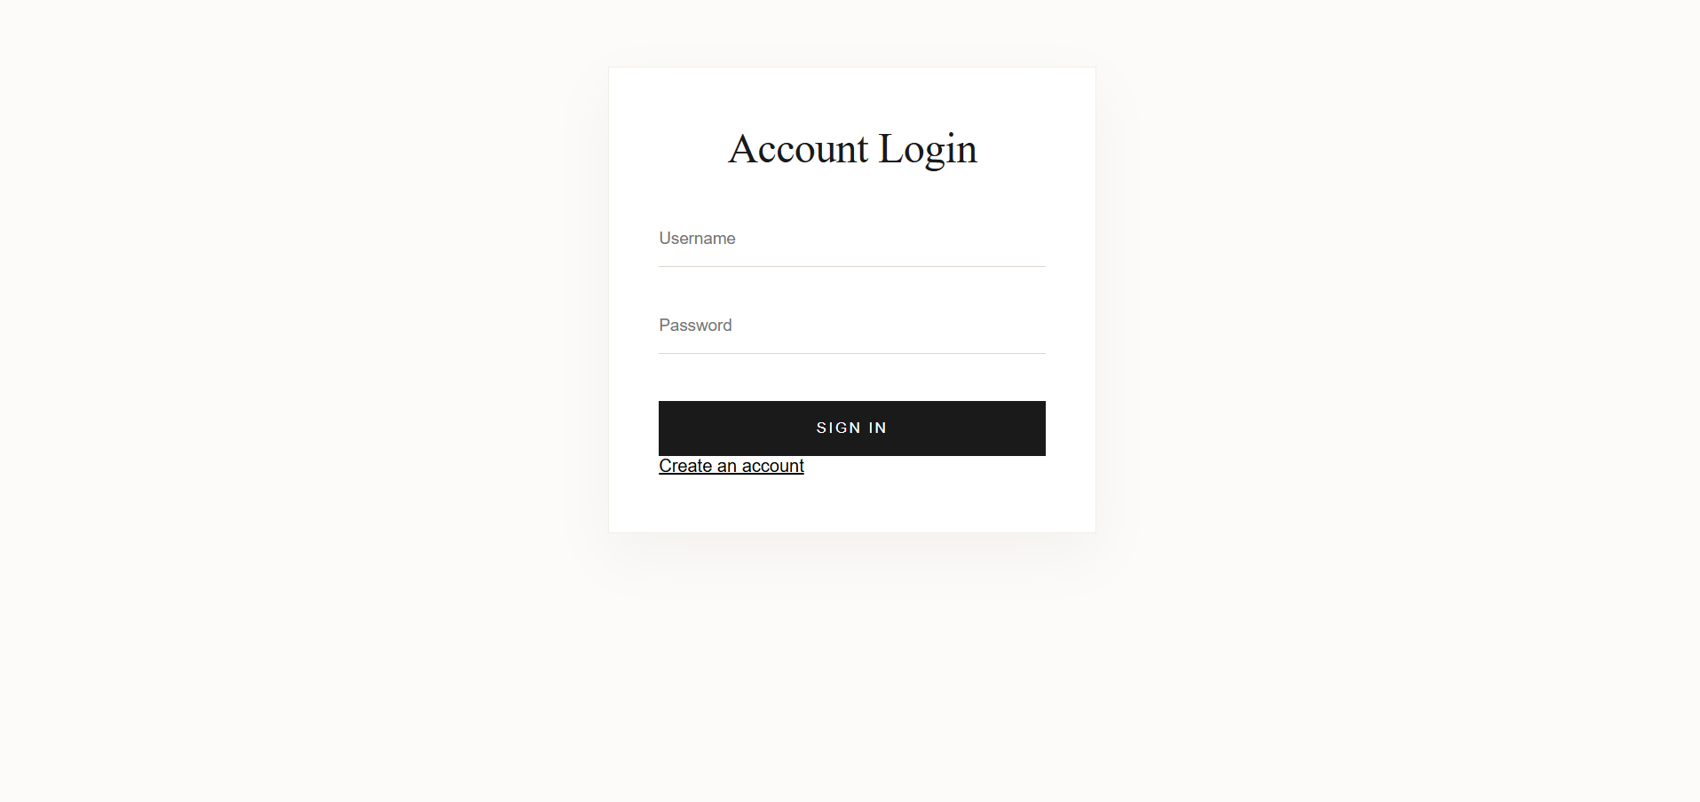

I contributed in designing the admin home page alongside my groupmates

Home page(if admin): admin personnel can navigate their various features

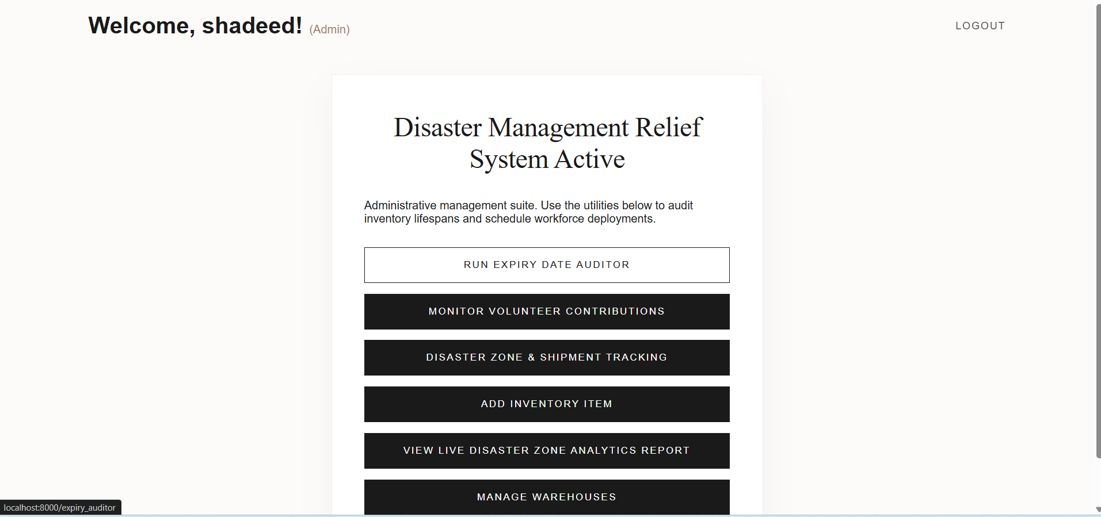

If customer but not volunteer: customers can choose to view active disaster zones or apply to become a volunteer.

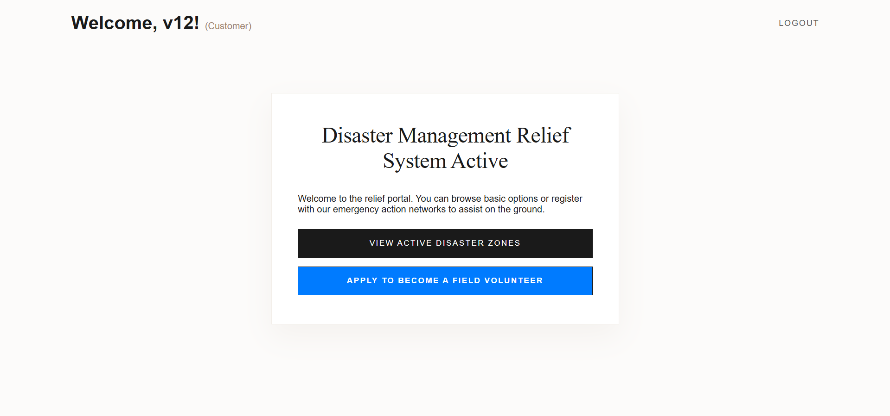

If volunteer: Volunteers can toggle their availability status.

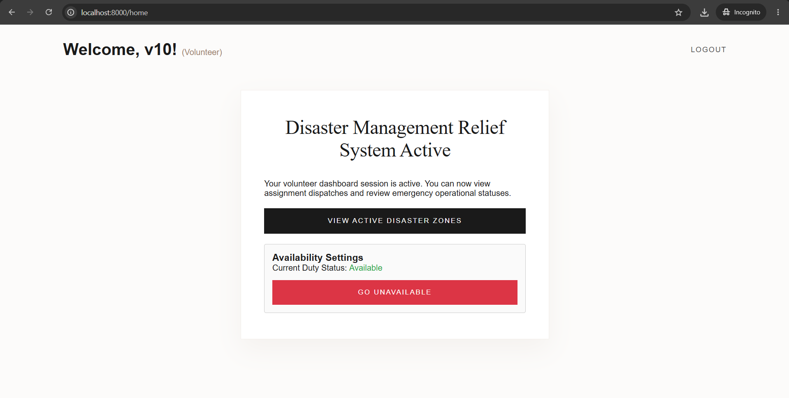

View_disaster_zones page:

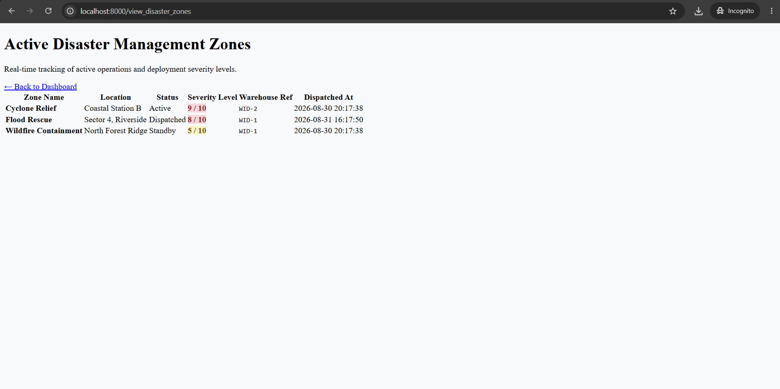

Volunteer_monitoring: Admin personnel can monitor volunteers, approve/remove them, see who is available and deploy them. They can also view active deployments.

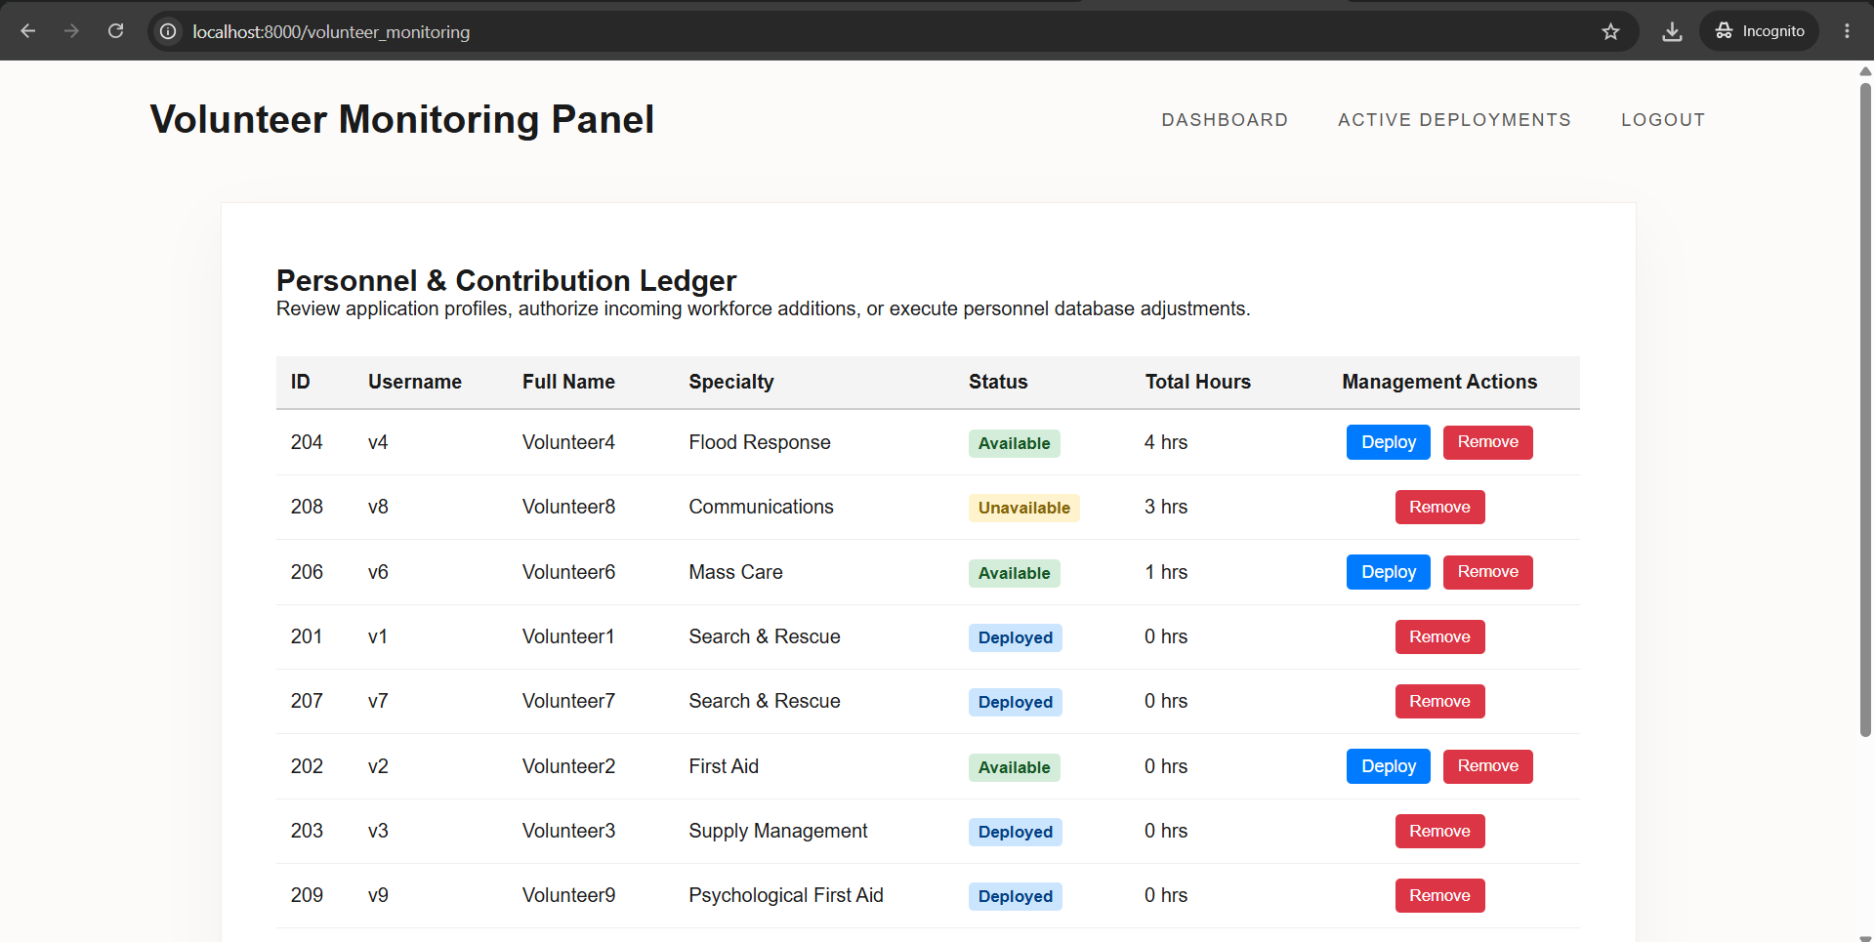

Active_deployments: Admin personnel can view current deployments. They can also release the volunteers from deployment.

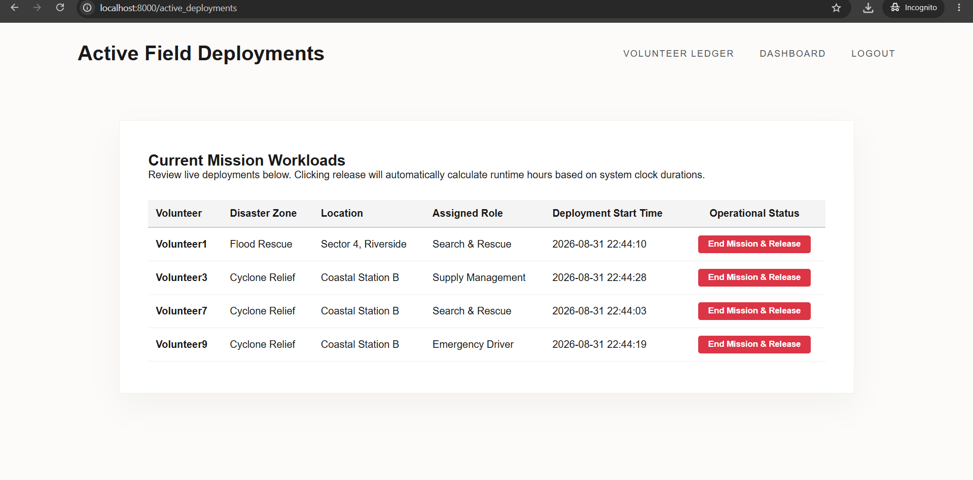

Deploy_volunteer: Here, admin can choose the options and details regarding deploying a volunteer.

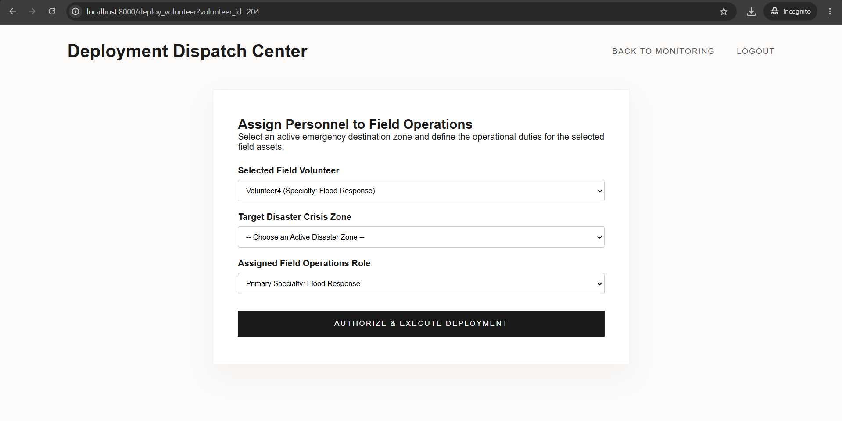

Become_volunteer: Menu for customers to become a volunteer by providing relevant information.

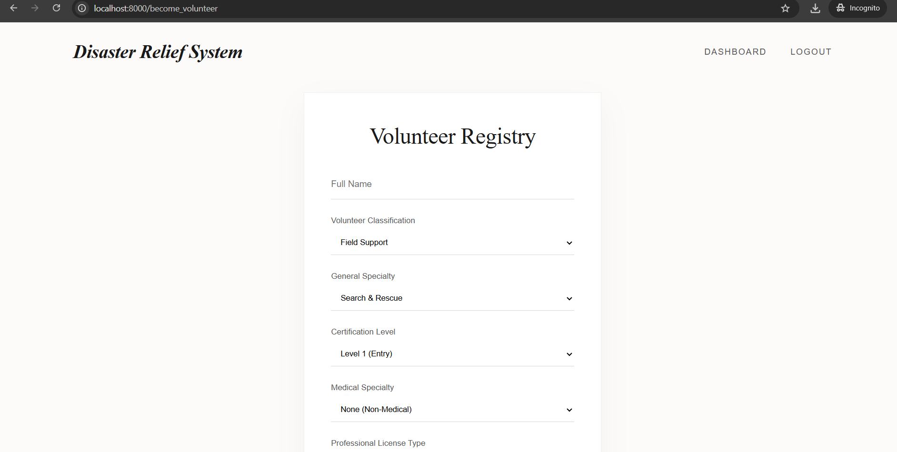

Contribution of ID: 24301348, Name: Kazi Aryan Rahman

In the frontend section, I designed the following administrative interfaces:

1. manage_zones page (Disaster Zone & Shipment Tracking): Interface for admins to declare new disaster zones and update the operational statuses of active ones.
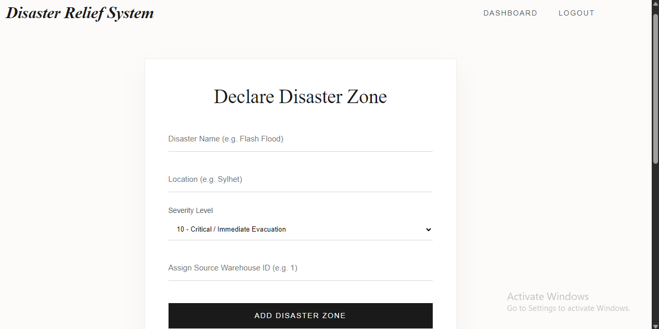
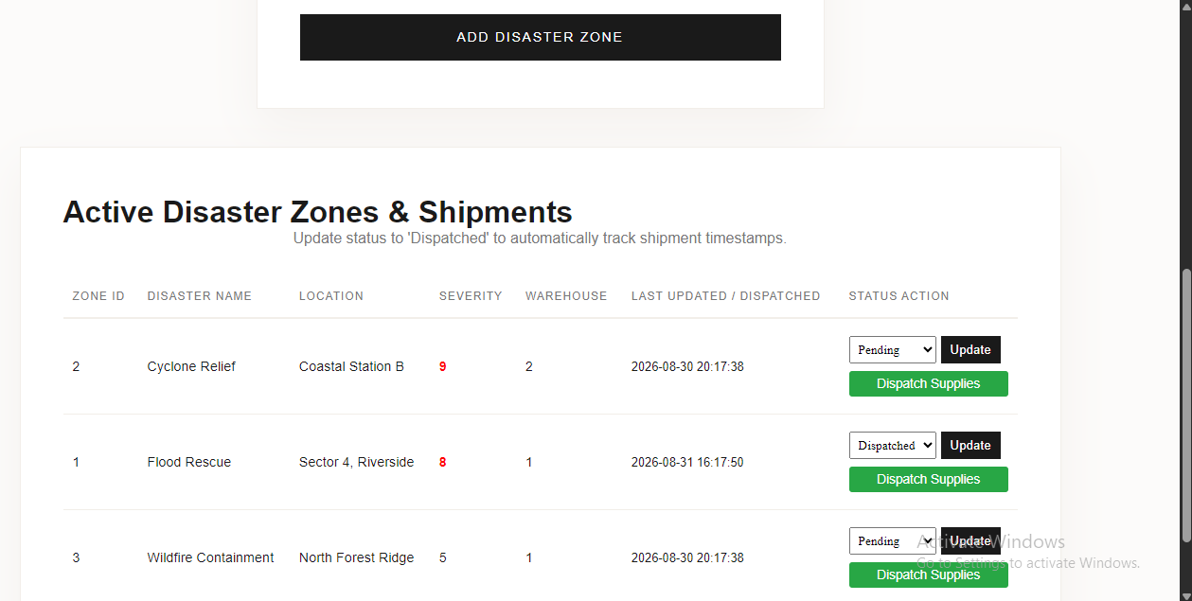
2. dispatch_shipment Page: Interface to validate and select available inventory from an assigned warehouse to dispatch to a specific crisis zone.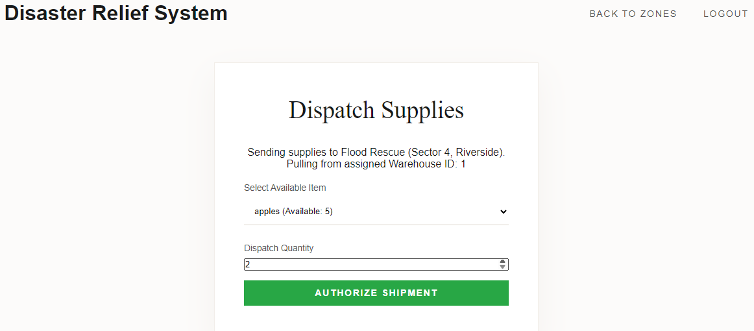

3. zone_analytics Page: Dashboard displaying a real-time, aggregated report on active volunteer deployments and total dispatched supplies per zone.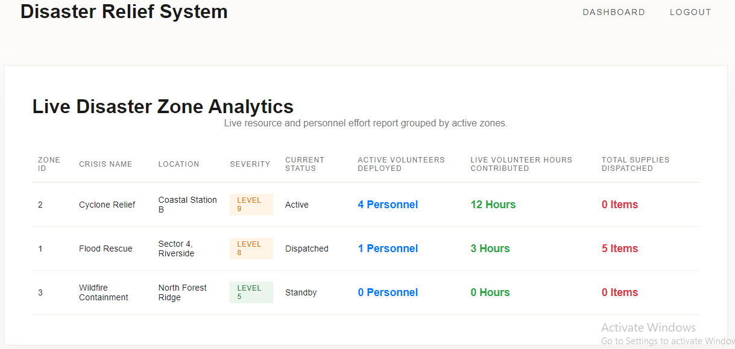

Contribution of ID: 24301362, Name: Nuzhat Tabassum Oishee

In the frontend section, I designed the following pages:

- Add_inventory page
This page adds an inventory item (which is seen in the expiry date auditor after being added) based on item name, category, quantity, and expiration date

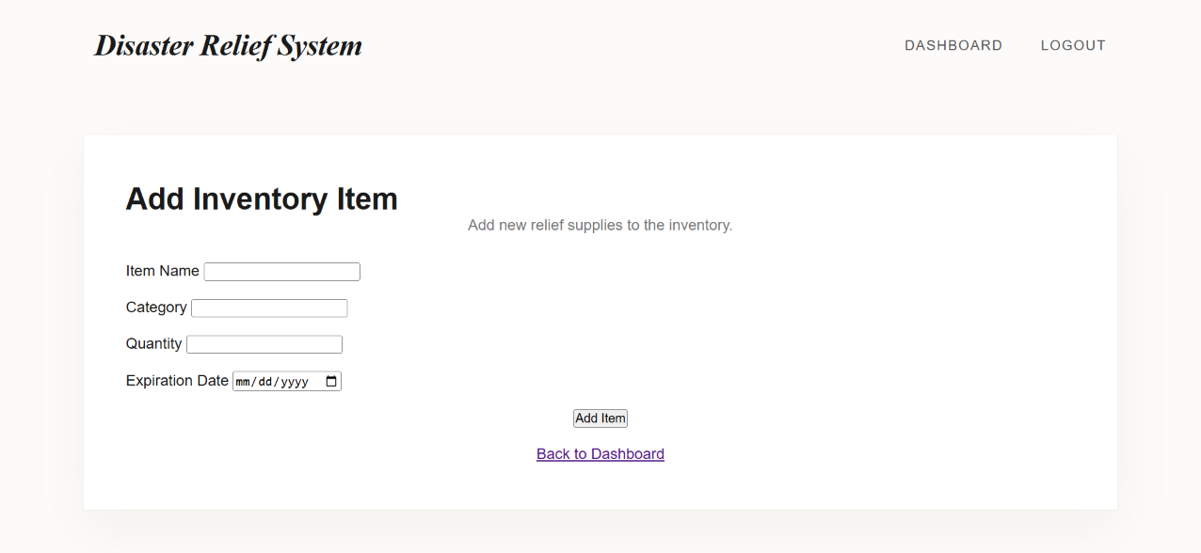
Adding an item, eg., chips here, will cause it to show up in the expiry date auditor
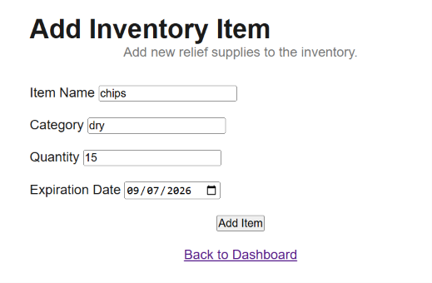
What we see in the expiry date auditor after adding it:
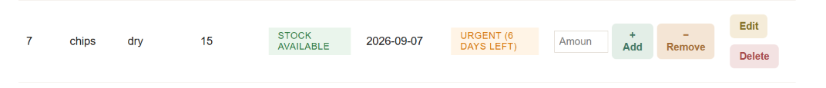

- Expiry date auditor page

The goal of this page is to view the added inventory items based on their shelf lives. We can see every inventory item’s name, category, quantity, expiration date and days left to expire. Moreover, based on their quantity, it tells us whether a restock is needed or not.
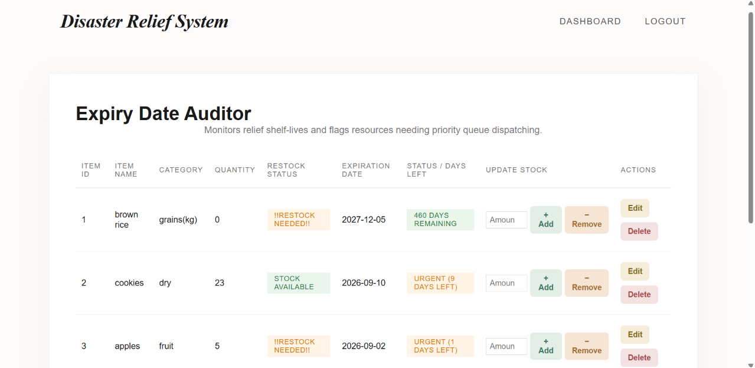
There’s also an option to update, add, or remove stock quantities. Eg.
Previously we had this
If we want to remove 5 of this item, then
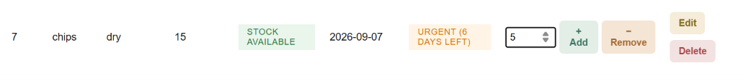
After updating, we can see

Additionally, we can edit or delete inventory items using the edit and delete buttons at the rightmost corner

Edit inventory page:
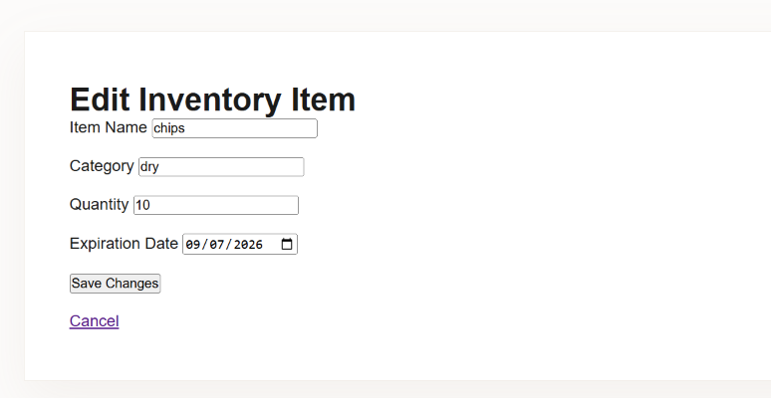

If we want to delete, then this shows up
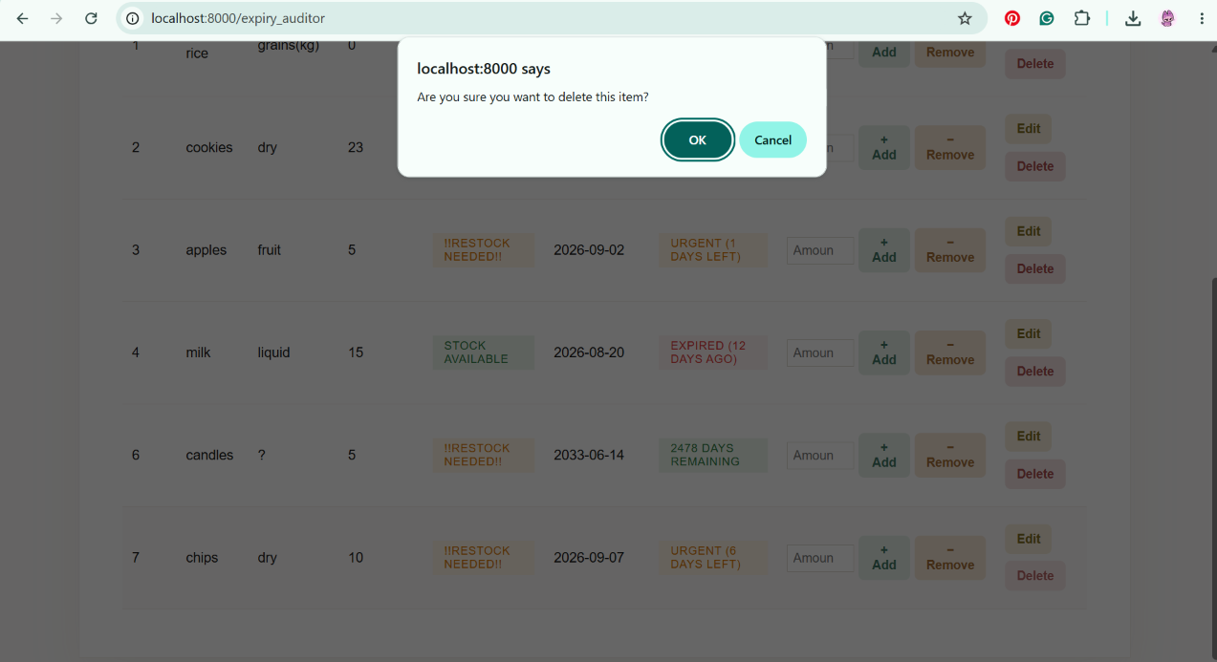

- Manage warehouse page
This page allows us to register warehouses, view the registered warehouses, assign inventory items to a warehouse, view a warehouse’s inventory stock, edit and delete a warehouse.

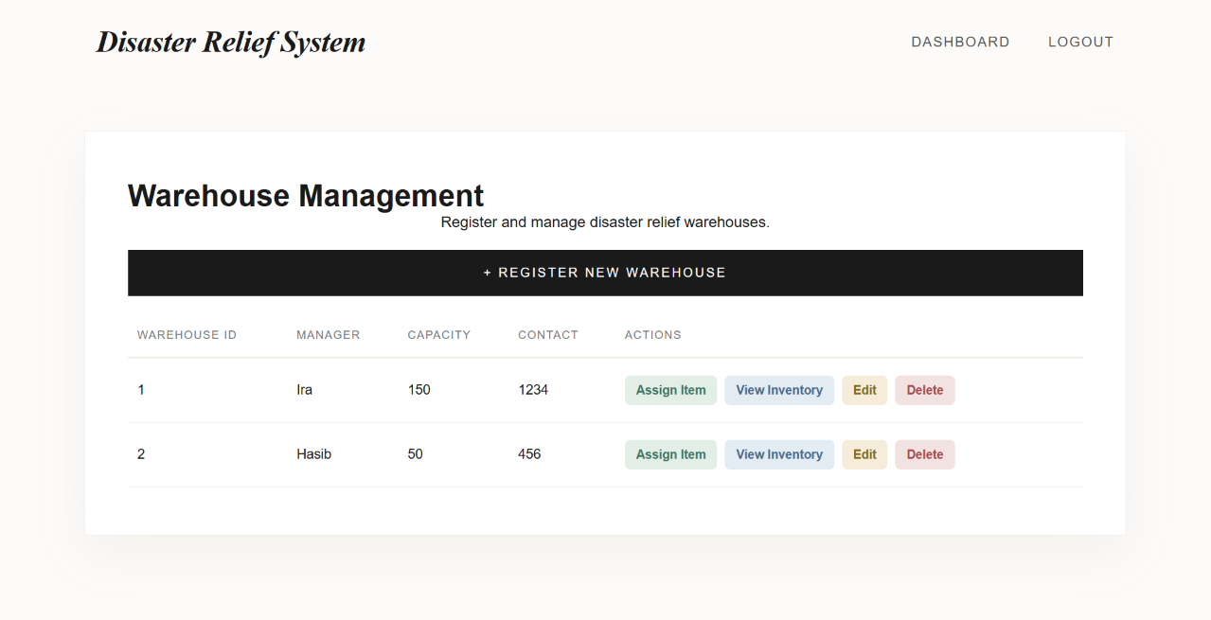
Registering a warehouse:
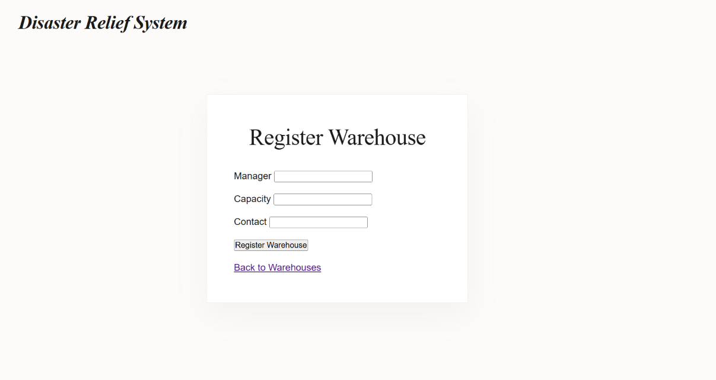

If we want to add a new warehouse, we have to register it first. Then it will show up in the warehouse management panel.

After that, we can assign items to that warehouse by selecting available inventory items and designating them to a shelf location.
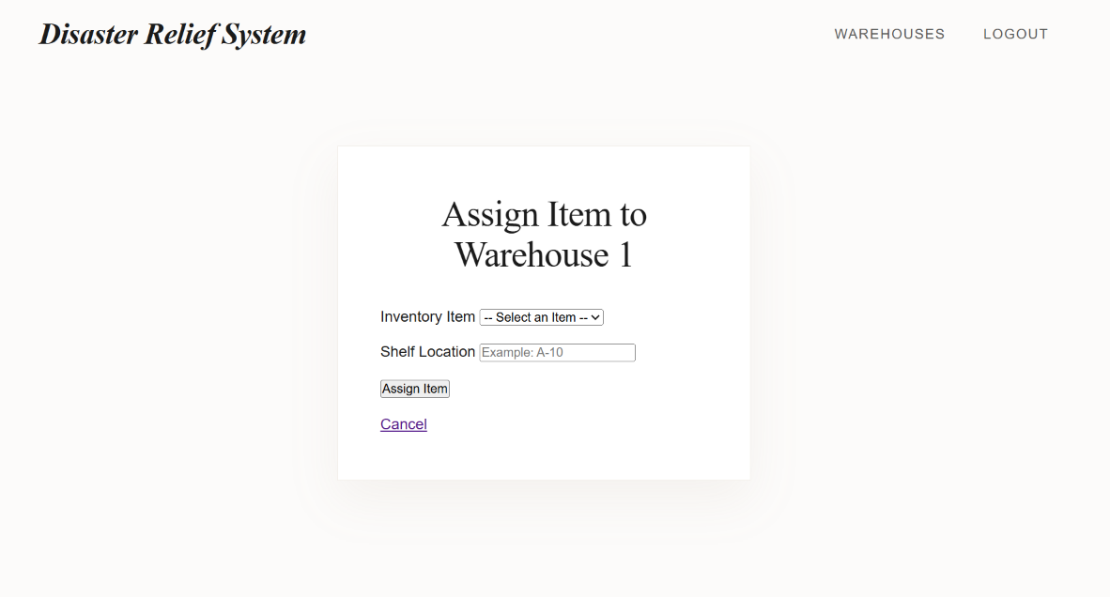

We can also view the inventory of a warehouse:
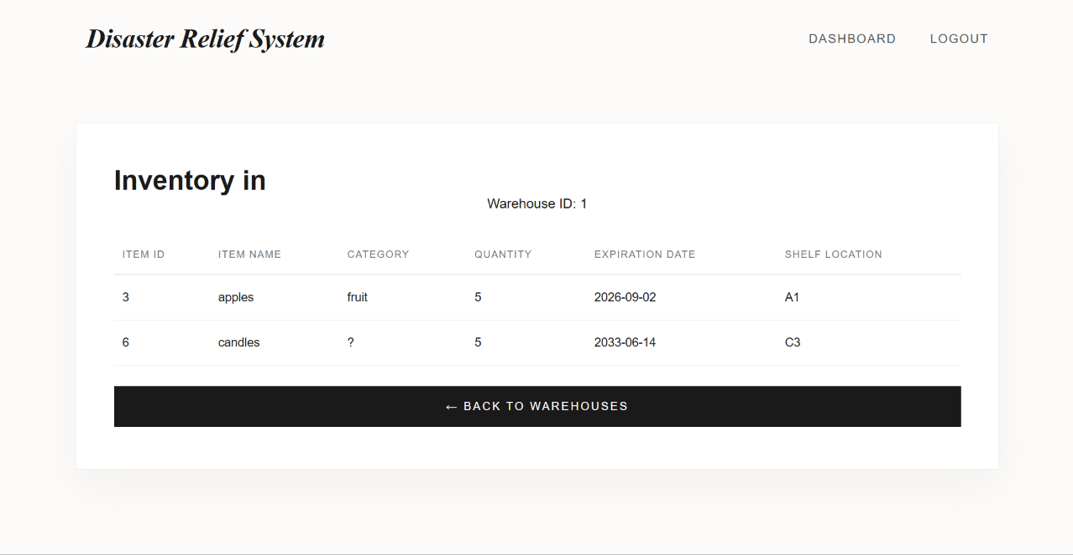

Editing a warehouse:
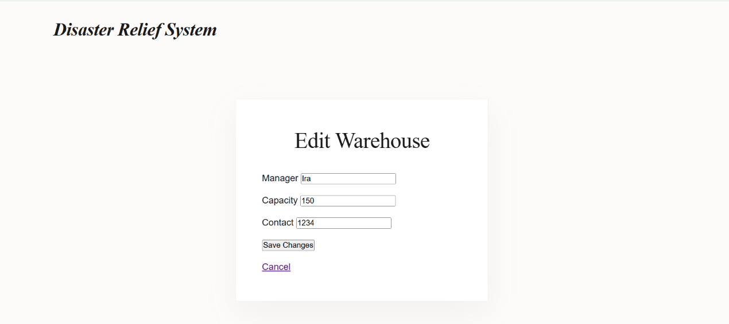

Deleting a warehouse:
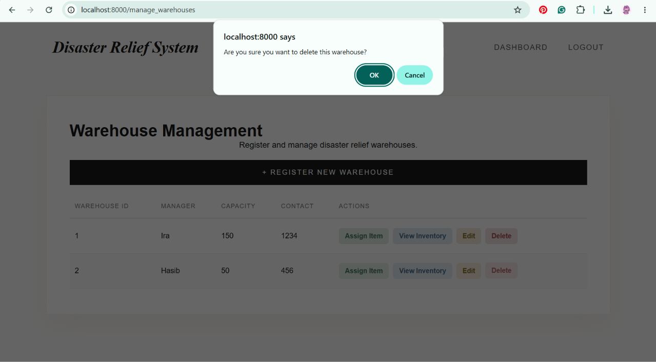

Backend Development

Briefly discuss about Backend Development and add relevant Screenshots (if required) by mentioning Individual Contributions

Contribution of ID : 24301374, Name : Shadeed Aarshan

We used Python with Flask for our project. I developed the login route for customers to enter their username and password. Following is the query running in the login route

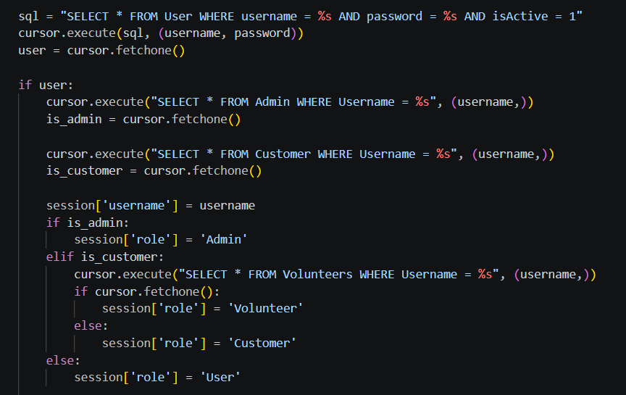

I developed the feature for customers to be able to apply as volunteers. This updates the volunteer table. Following is the query in the /become_volunteer route

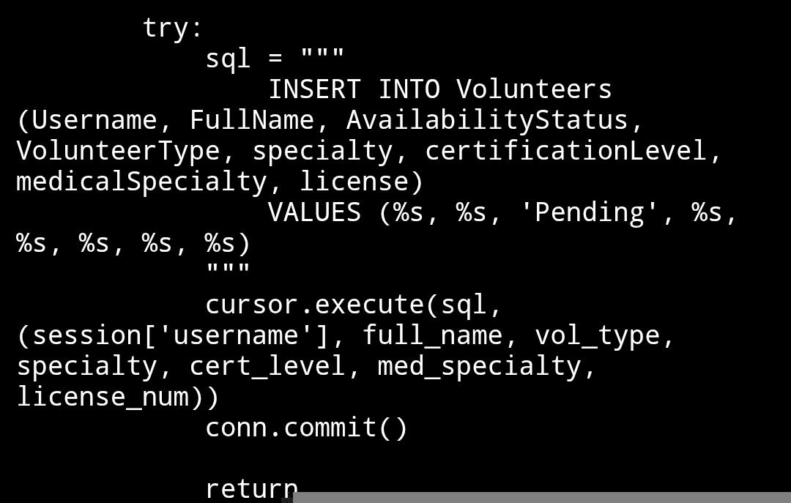

Admin can monitor volunteers through the /monitor_volunteer route

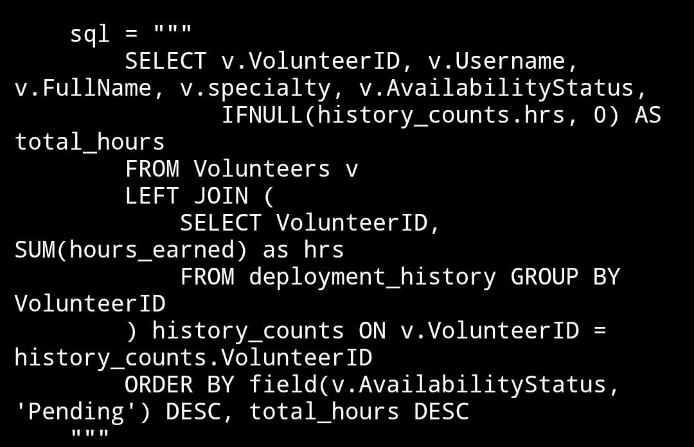

Connecting with the previous feature, I developed the admin feature of approving/removing volunteers. Following pictures are the queries ran by the /approve_volunteer and /remove_volunteer routes respectively.

/approve_volunteer

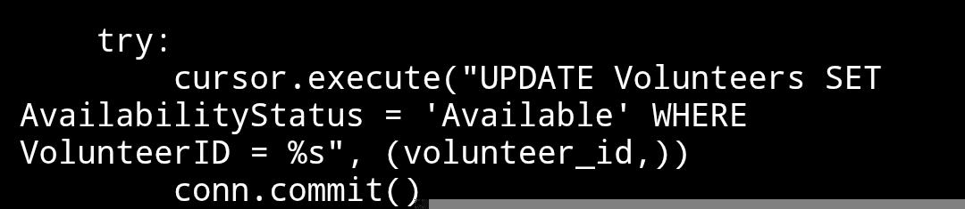

/remove_volunteer
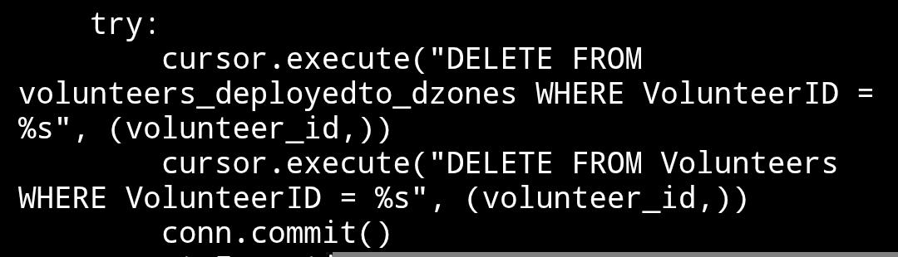

I developed the admin feature of being able to deploy/release volunteers to and from disaster zones. Admin can also view current deployments.

/deploy_volunteers
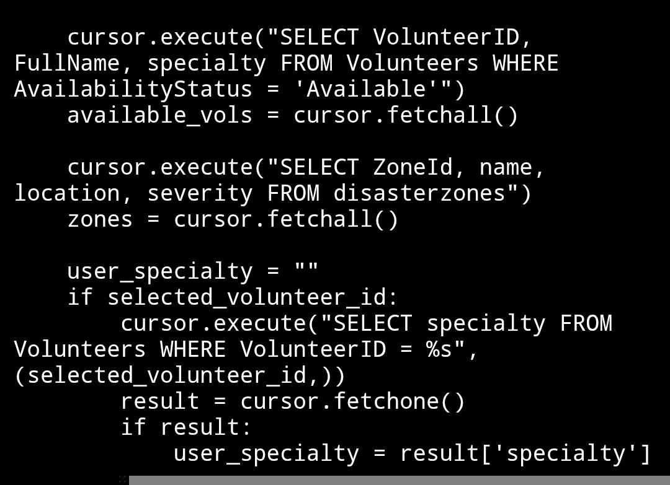

/process_deployment
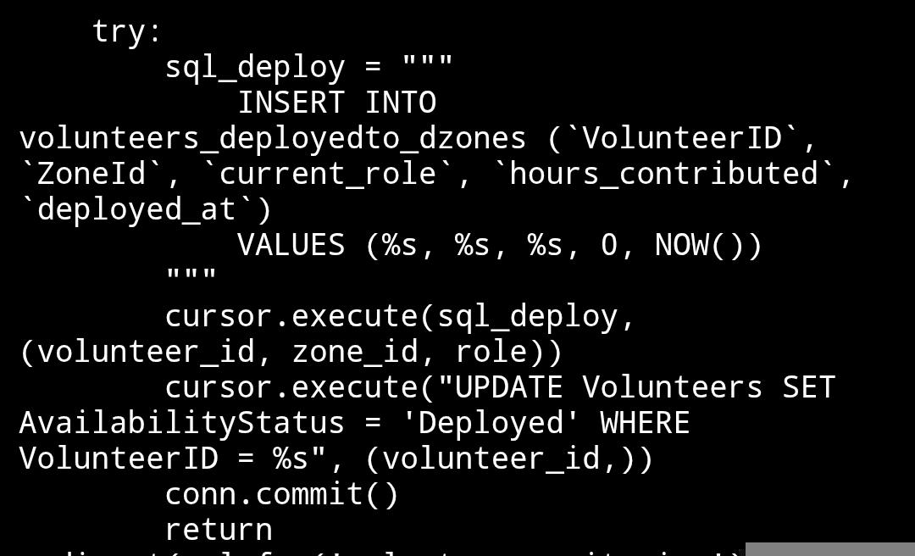

/active_deployments
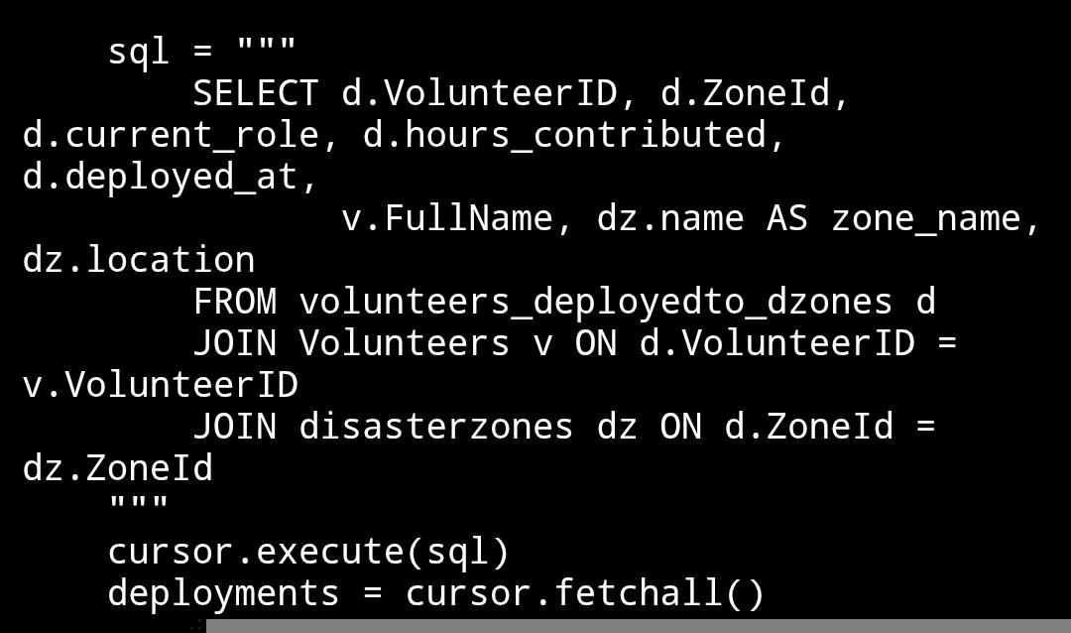

/release_volunteer
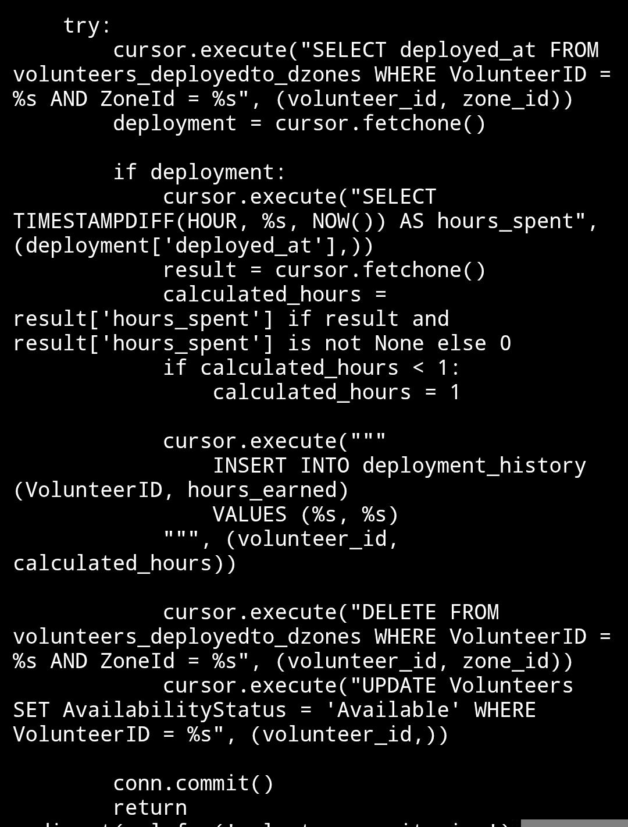

Finally, I developed the customer feature to be able to toggle their availability. If they are unavailable, they cannot be deployed.

/volunteer/toggle_availability

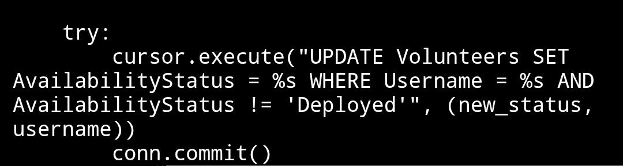

Contribution of ID : 24301348, Name : Kazi Aryan Rahman
I developed the Disaster Zone & Shipment Tracking feature, which lets admins declare new disaster zones and assign them a severity level and a source warehouse. Zones are listed ordered by severity so the most critical ones surface first, and admins can update a zone's operational status as relief progresses.
/manage_zones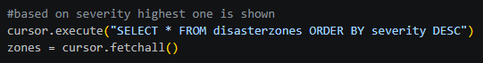
/add_zone 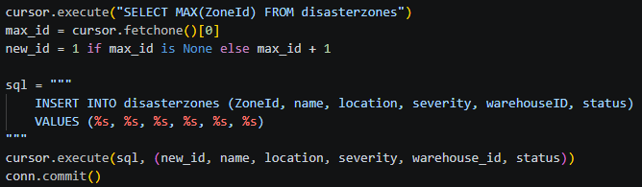
/update_zone/<zone_id>
Building on that, I developed the Relief Shipment Dispatcher. It pulls the items currently available in a zone's assigned warehouse, then on submission checks that enough stock exists, deducts the dispatched quantity from inventory, records the dispatch in a permanent shipment log, and automatically updates the zone's status to 'Dispatched' with a timestamp.

/dispatch_shipment/<zone_id> — GET (load items available in the zone's warehouse) 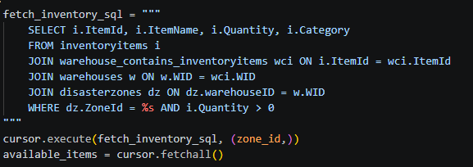
/dispatch_shipment/<zone_id> — POST (validate stock, deduct inventory, log shipment, update zone status)
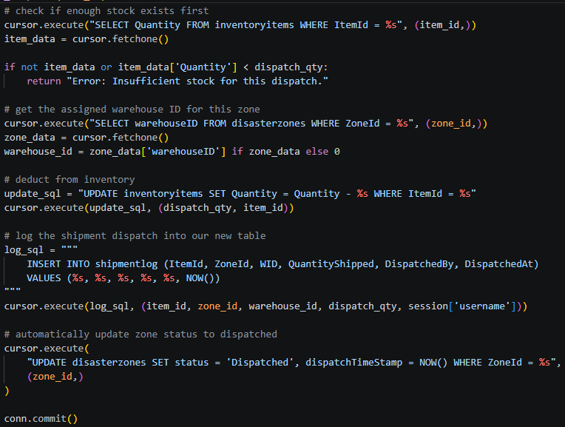
Finally, I developed the Live Disaster Zone Analytics & Resource Report — a single aggregation query joining zones with their deployed volunteers and shipment log to report, per zone, active personnel, live accumulated volunteer hours, and total supplies dispatched, ordered by severity.
/zone_analytics 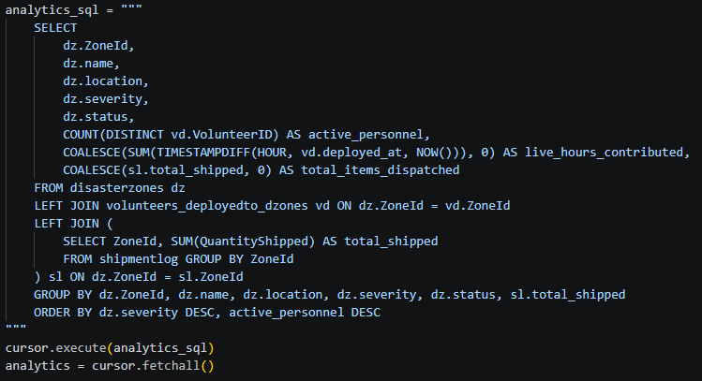

Contribution of ID: 24301362, Name: Nuzhat Tabassum Oishee

I developed the features that handled the viewing, adding, editing, and deleting of inventory items. To add an item to the inventory:
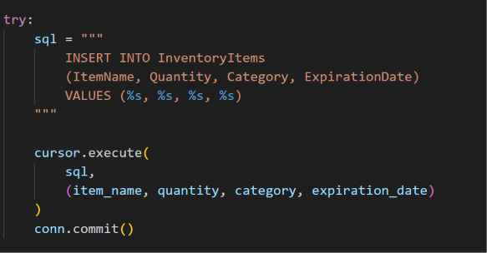

To edit an item:
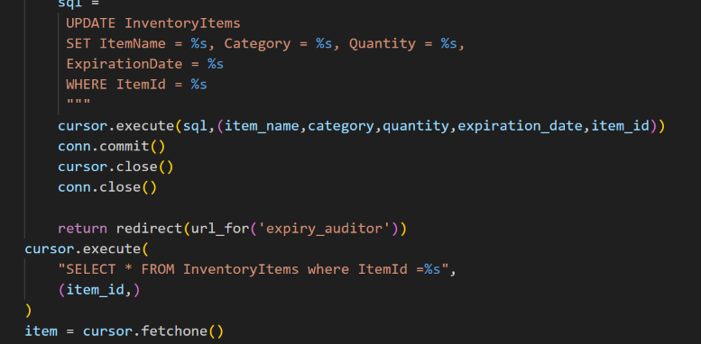

To delete an item:
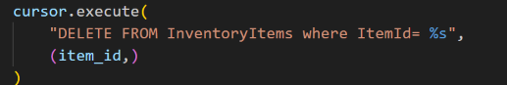

The added inventory items can be seen in the expiry date auditor, which runs the following query:
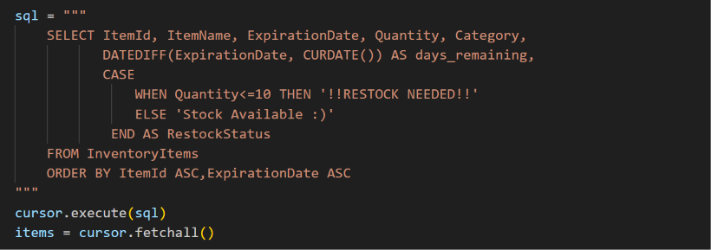

From the expiry date auditor, we can update our inventory stock:
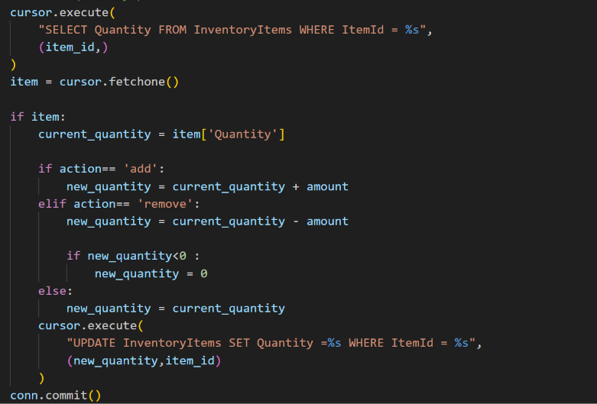

Moreover, one of my features had to manage warehouses and their corresponding inventory stock by shelf number. To view warehouses:

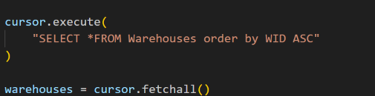

To add/register a warehouse:
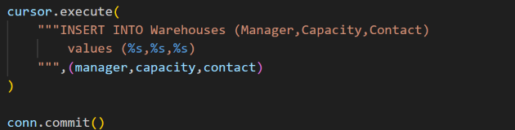

To edit warehouses:
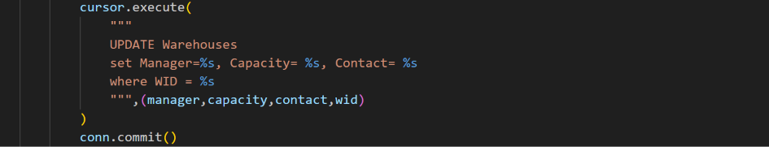

To delete a warehouse:
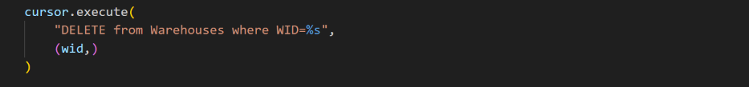

To assign an inventory item to a warehouse:
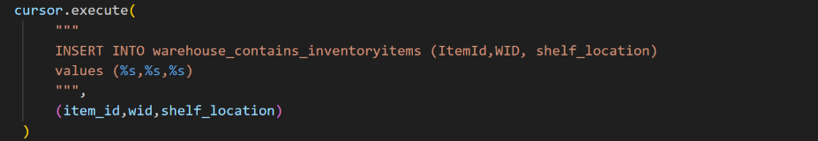
The query below allows us to choose the inventory items from a (dropdown) list:
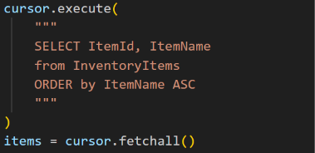

Finally, to view the inventory in a warehouse:
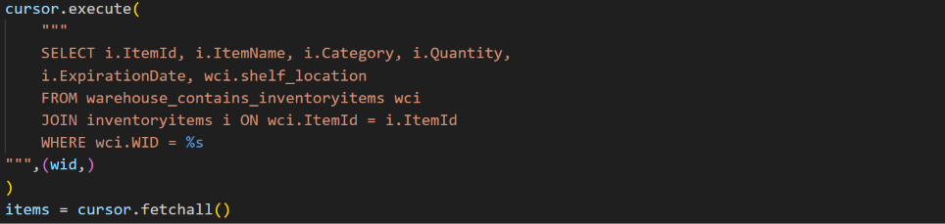

Source Code Repository

Google Drive link with Project Source Code:

Google Drive: https://drive.google.com/drive/folders/1jyuPn6trXx8PWMf4x6A1wl15ViQ7elGS?usp=drive_link
GitHub:
https://github.com/oishee296/CSE370_Group08_S11_Summer2026

Conclusion

References

